Embedding Models: Key Attributes and Selection Criteria
Purpose:
This research aims to conduct an in-depth study of different embedding models to understand their strengths, limitations, and ideal use cases.
- Explore a wide range of embedding models in detail
- Analyze differences in architecture, dimensions, context length, and training objectives
- Study performance across various tasks and domains
- Understand trade-offs between accuracy, speed, scalability, and cost
Outcome
The goal is to clearly identify:
- Which embedding models perform best
- Under what conditions they perform best
- Which model is most suitable for specific use cases
Overview:
Embedding models transform text (or other data) into fixed-length vectors that capture semantics. They vary widely in architecture (e.g. static word vectors vs deep Transformer encoders), embedding dimension, maximum context length, training data/domain, and performance on tasks. For example, early models like Word2Vec/GloVe/FastText produce ~300-dimensional static word embeddings, while modern Transformer-based models (BERT, RoBERTa, T5, etc.) generate contextualized embeddings of 768–4096 dimensions. OpenAI’s text-embedding models produce up to 3072 or more dimensions (e.g. text-embedding-3-large is 3072-D) and handle long contexts (~8191 tokens)[1][2]. In contrast, compact models like MiniLM yield 384-D embeddings with much lower latency. Selecting a model depends on task needs: long context (some models handle 16K tokens), multilingual support, domain specificity (general vs medical/legal text), and compute constraints (GPU vs CPU). Crucially, larger dimension often means richer semantic detail but higher cost; as one guide notes, “larger embedding dimensions can capture more nuance, but aren’t always better”[3]. For instance, a 384-D embedding can save ~60% storage versus a 1024-D one with minimal performance drop[3][4].

Before starting research about the embedding models, let us see how important it is:
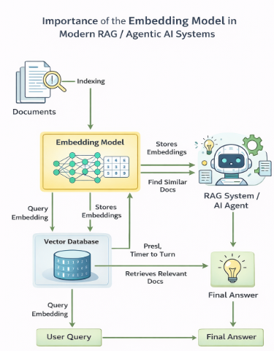
Popular embedding models (text) include:
Category | Model | Embedding Dim | Max Context (Tokens) | Best For | Notes
BERT Family | bert-base-uncased | 768 | 512 | General NLP tasks | Contextual embeddings
 | DistilBERT | 768 | 512 | Faster inference | Smaller & lighter than BERT
Sentence-BERT | all-mpnet-base-v2 | 768 | 512 | Semantic search | Strong similarity performance
MiniLM | all-MiniLM-L6-v2 | 384 | 512 | Speed + low memory | Great cost-performance balance
Universal Sentence Encoder | Universal Sentence Encoder | 512 | ~512 | General semantic tasks | Lightweight Google model
OpenAI Embedding | text-embedding-ada-002 | 1536 | 8191 | Long-context search | API-based, high quality
Multilingual SBERT | paraphrase-multilingual-mpnet-base-v2 | 768 | 512 | Cross-lingual search | 50+ languages
Biomedical | BioBERT | 768 | 512 | Medical NLP | Trained on PubMed
Scientific | SciBERT | 768 | 512 | Research papers | Scientific corpus
Long Context | Longformer | 768 | 4096–16384 | Long documents | Sparse attention
 | LED | 768 | Up to 16K | Long doc summarization | Encoder-decoder
Instruct Model | voyage-lite-02-instruct | 1024 | ~4K | Instruction-tuned semantic tasks | Optimized for search
Classical Embeddings | Word2Vec | 300 | N/A | Ultra-fast systems | No context awareness
 | GloVe | 300 | N/A | Legacy systems | Static vectors
 | FastText | 300 | N/A | OOV handling | Subword-based

Each model’s documentation or papers provide these specs. For example, OpenAI’s docs list dimensions and token limits (e.g. ada-002 is 1536-D, 8191 tokens)[1]. Table summaries from model hubs (e.g. Hugging Face) often list embedding_dimension and max_sequence_length for each model. We recommend extracting: Dimensionality, Max Context (tokens), Model size, Training corpus/domain, Language support, and License/availability when comparing.

Evaluation Metrics for Embeddings
To compare models, we cluster metrics into three categories:
- Semantic/Retrieval Metrics: Measure how well embeddings capture meaning for tasks like search or similarity. Common metrics include Recall@K (what fraction of true relevant items appear in the top-K) and Precision@K[10][11]. For ranking, Mean Reciprocal Rank (MRR), Mean Average Precision (MAP), and NDCG are used[11][12]. For semantic similarity tasks, correlations with human judgments (e.g. STS benchmark scores) are used. Cosine similarity between vectors is the typical similarity measure, so higher similarity should correspond to semantic relatedness. Tools like TREC evaluation can compute these metrics for retrieval.
- Downstream Task Metrics: If embeddings feed into tasks (classification, clustering, etc.), measure end-task performance. For classification: Accuracy, Precision/F1, AUC-ROC, etc. For clustering: metrics like Silhouette score or Adjusted Rand Index compare cluster quality to known labels[13]. These reflect how well embeddings separate data in real use. For example, embeddings might be tested by training a classifier on top of them, or by clustering documents and evaluating cluster purity.
- Efficiency and Model Metrics: These include inference time, throughput (vectors/sec), model size (parameters and memory), and vector storage cost. Embedding dimension itself is a resource metric (larger dims mean more memory and slower nearest-neighbor searches). As one guide notes, “evaluate inference speed… some models require GPUs, others run efficiently on CPUs”[14]. For instance, all-MiniLM-L6-v2 (384-D) is much faster than a 3072-D model but may have slightly lower accuracy[14][5]. Benchmarking on the target hardware (CPU/GPU) and estimating storage (e.g. 1M vectors × D floats) is essential. Metrics like Queries Per Second (QPS) with FAISS/Annoy on representative data quantify runtime performance.
When shortlisting models, one should balance quality (semantic accuracy) and practicality (latency, cost). For example, Milvus recommends small models for quick baselines, then larger ones once the pipeline is stable[3][14].

Massive Text Embedding Benchmark (MTEB) Coverage
The Massive Text Embedding Benchmark (MTEB) provides a comprehensive evaluation suite. It comprises 56 datasets across 8 task families (Classification, Clustering, Bitext mining, STS, Retrieval, Pair classification, Reranking, Summarization) and over 2000 model results[15]. It even includes multilingual tasks (112 languages). The figure below illustrates MTEB’s tasks and datasets:
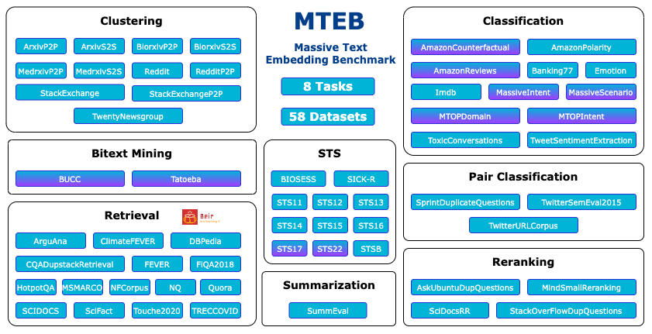
Figure: The MTEB covers 8 tasks and 58 datasets for evaluating text embeddings across NLP domains (classification, clustering, retrieval, STS, etc.)[15].
MTEB’s public leaderboard ranks ~30–40 models on each task. It emphasizes trade-offs: for example, it shows that large instruction-tuned models (e.g. SGPT-5.8B-msmarco) achieve top accuracy but output 4096-D vectors (huge storage cost), while compact models (like all-MiniLM-L6-v2 or all-mpnet-base-v2) offer a better speed-vs-performance balance[5]. Thus, MTEB results (or similar benchmarks) are a useful reference for initial filtering.

Example Models and Where to Use Them
Here are representative embedding models and their typical uses:
Model | Dim | Max Tokens | Model Size | Best Use Case | Strength | Limitation
sentence-transformers/all-mpnet-base-v2 | 768 | 512 | ~110M | Semantic search, clustering | Balanced performance across tasks | Cannot handle long documents (>512 tokens)
all-MiniLM-L6-v2 | 384 | 512 | ~22M | Real-time search, low-resource systems | Very fast, low memory | Slight accuracy drop vs 768-D models
text-embedding-ada-002 | 1536 | 8191 | API-based | Long documents, high recall search | Handles long input, strong generalization | Slower, cloud cost per token
sentence-t5-xxl | 768 | 512 | ~11B params | High-end evaluation, research benchmarks | Very high MTEB scores | GPU-heavy, slow inference
BioBERT / LegalBERT | 768 | 512 | ~110M | Medical / Legal QA | Domain-specialized accuracy | Poor general-domain transfer
allenai/led-base-16384 | 768 | 16384 | ~162M | Extremely long documents | Supports very large context | Some semantic compression loss
TF-IDF / Word2Vec | 300 | N/A | Very small | Ultra-fast baseline systems | Extremely fast | No contextual understanding
Each model’s documentation (e.g. Hugging Face model card or research paper) should be consulted for details. For example, Graft’s blog lists many models with dims and intended use[19][20] (though we rely on authoritative sources when citing).

Selection Criteria and Decision Process
When starting with many candidate models, filter by application requirements:
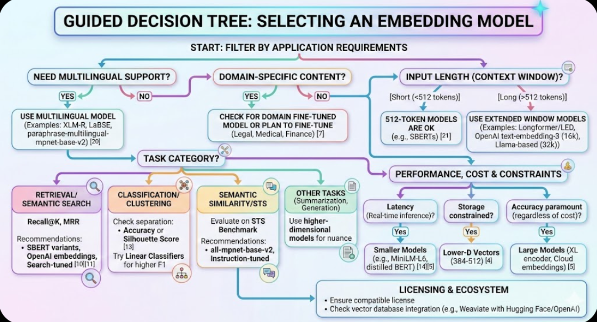

- Task Category:
- Retrieval/Semantic Search: Prioritize models with high Recall@K on retrieval tasks. SBERT variants, OpenAI embeddings, or models fine-tuned for search often excel. Use an information retrieval metric (e.g. recall@5, MRR) on a small representative QA set[10][11].
- Classification/Clustering: Embeddings must separate classes. Use accuracy or silhouette score on labeled data to compare models[13]. For classification pipelines, try linear classifiers on the embeddings to see which model yields higher F1.
- Semantic Similarity/STS: Evaluate on an STS benchmark. Models like all-mpnet-base-v2 or instruction-tuned ones often do well.
- Other tasks: For summarization or generation, embeddings might be used to group contexts; here higher-dimensional models may capture more nuance, but empirical tests on your data are needed.
- Domain and Data:
- If your content is domain-specific (legal, medical, technical), general embeddings may miss key terms. Use domain-adapted models or fine-tune. For example, Weaviate notes domain models exist for finance, law, healthcare and recommends checking if one suits your data[7].
- For multi-lingual needs, ensure the model is trained on the target languages. Models like XLM-R or LASER support many languages; generic BERT does not.
- Input Length (Context Window):
- Match chunk size to model: If your use case involves chunking paragraphs (<512 tokens), most models suffice[21]. For longer passages, use models with extended windows (Longformer/LED up to 4096–16384 tokens) or chunk with overlap.
- Embedding models like OpenAI’s text-embedding-3 (16k tokens) or Llama-based embeddings (32k tokens) are choices for very long contexts.
- Performance vs Cost:
- Precision vs Recall: Some models optimize different metrics. The Milvus example shows SBERT had high recall on technical docs but struggled with casual language, whereas OpenAI’s model was better on diverse language[18]. Consider a mix or ensemble if needed.
- Latency and Resources: If real-time response is needed, favor smaller models (e.g. MiniLM, distilled BERT)[14]. If batch speed is less critical, larger models or cloud APIs with higher quality embeddings may be chosen.
- Dimension/Storage: Constrain dimension if storage is a concern. Lower-D vectors (384–512) are much cheaper to index and search, as noted above[4]. However, too low may degrade recall. Pick a dimension that balances storage with desired accuracy.
- Licensing and Ecosystem:
- Ensure the model’s license is compatible (open-source vs proprietary). If using a vector database, some have native integration with specific models (e.g. Weaviate with OpenAI, Hugging Face).

Benchmarking Experiments
To establish ground truth for recall/precision, one must curate a test set: select representative queries and known relevant documents (e.g. legal Q&A for a legal RAG system). Then for each model:
- Encode all documents and queries using the model’s embedder (same normalization).
- Perform nearest-neighbor search (e.g. cosine similarity in FAISS) to retrieve top-K for each query.
- Compute retrieval metrics (Recall@K, Precision@K, MRR) by comparing to ground-truth relevance. As Milvus suggests, using TREC tools or custom scripts can automate recall/precision computation[10].
- Evaluate downstream tasks: e.g. use embeddings as features in your classification pipeline and measure accuracy/F1.
- Measure efficiency: Record embedding time per sentence and memory use (vector size, index size).
By comparing models on your actual data, you know which works best in context. (MTEB is a starting point, but its datasets may differ from your domain.)

Summary
In practice, narrow down models by filtering on your key criteria (domain, languages, latency). Then benchmark a handful on your data. Use metrics from retrieval, classification, etc., as relevant[12][13]. Consider a two-stage pipeline: e.g. use a fast, moderate-accuracy model for initial retrieval, then re-rank top results with a slower cross-encoder if needed. Keep the decision process flexible: as one expert notes, “model performance varies by task and dataset, so test models side-by-side to find the best fit[22].” Ultimately, select the top models that deliver the required precision/recall at acceptable cost.
References:
[1] [2] The guide to text-embedding-ada-002 model | OpenAI
https://zilliz.com/ai-models/text-embedding-ada-002
[3] [21] Step-by-Step Guide to Choosing the Best Embedding Model for Your Application | Weaviate
https://weaviate.io/blog/how-to-choose-an-embedding-model
[4] [6] [10] [14] [18] How can we evaluate different embedding models to decide which yields the best retrieval performance for our specific RAG use case?
https://milvus.io/ai-quick-reference/how-can-we-evaluate-different-embedding-models-to-decide-which-yields-the-best-retrieval-performance-for-our-specific-rag-use-case
[5] [15] [22] MTEB: Massive Text Embedding Benchmark
https://huggingface.co/blog/mteb
[7] [11] Why, When and How to Fine-Tune a Custom Embedding Model | Weaviate
https://weaviate.io/blog/fine-tune-embedding-model
[8] [9] [16] [19] [20] Graft - 15 Best Open Source Text Embedding Models
https://www.graft.com/blog/open-source-text-embedding-models
[12] [13] [17] What metrics should I use to compare different embedding models? - Zilliz Vector Database
https://zilliz.com/ai-faq/what-metrics-should-i-use-to-compare-different-embedding-models

